F TIMES

Opinion Globalisation
The optimists were right and can be so again
We cannot wait for another period of catastrophe before we attempt renewal
MARTIN WOLF

© James Ferguson
Martin Wolf
YESTERDAY Dic 13, 2022

Is our world getting better and likely to continue to do so or is it sitting on the edge of catastrophe? People who think about these questions tend to divide sharply into the cheerful optimists, who believe the former, and the gloomy pessimists, who insist on the latter. I am in the former camp. But I would also make an important caveat. Continuing progress depends on managing the dangers we ourselves have created. Among these are destruction of the planetary environment and thermonuclear war. To succeed we must overcome forces of division, within and among countries, that threaten social stability, global co-operation and peace. In sum, the world can be a better place. But we cannot take for granted that it will be.

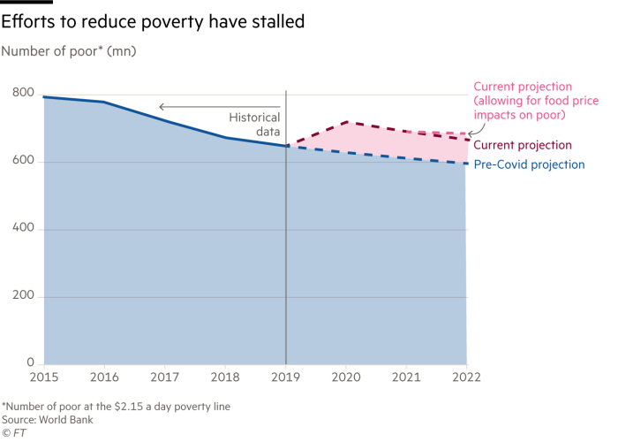

An optimistic view of the past is contained in the Human Development Report 2021/2002 from the UN Development Programme and Poverty and Shared Prosperity 2022 from the World Bank. The latter shows, for example, that the proportion of the world’s population living in extreme poverty (now measured at an income of less than $2.15 a day) fell from close to 60 per cent in 1950 to 8.4 per cent in 2019. That is staggering. Similarly, the UN’s human development index — an amalgamation of national income per head, years of schooling and life expectancy at birth — also shows a substantial and steady rise from 1990 to 2019. Again, the World Happiness Report 2022 shows that the happiest countries are prosperous — and, interestingly, small — ones, with Finland and Denmark at the head of its list. Average prosperity may not be a sufficient condition for greater happiness. But prosperity helps.

Not surprisingly, the pandemic reversed progress. The number of people in extreme poverty jumped from 648mn in 2019 to 719mn in 2020. Worse, it may mean that the numbers in extreme poverty will be permanently higher than they would otherwise have been. Again, the human development index is estimated to have declined in both 2020 and 2021, erasing gains of the previous five years. The energy and food crises brought about by Russia’s war in Ukraine will surely prolong the losses. The human consequences of these twin shocks then are unquestionably huge.

One might assume that normal economic service will ultimately be resumed. Yet the Human Development Report suggests that this hope might not materialise. It points to today’s “uncertainty complex”, as crises pile up one upon the other. Covid-19 is not, it suggests, a “long detour from normal; it is a window into a new reality”.

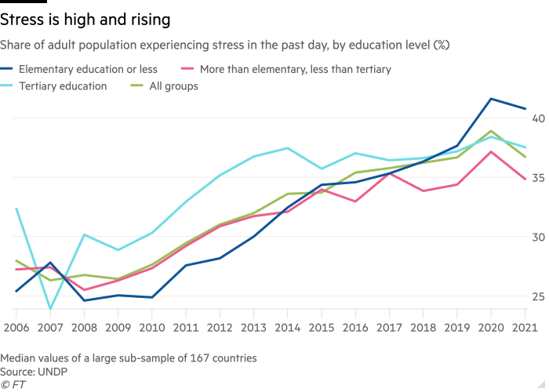

Yet it is also true, as the report shows, that the response to Covid included the speedy discovery and development of effective vaccines. Thus, “in 2021 alone Covid-19 vaccination programmes averted nearly 20mn deaths”. The distribution of these vaccines has been horribly unequal and the response has too often been one of ignorant hostility. But they worked. So, why be so pessimistic?

This “uncertainty complex” consists, suggests the report, of three elements: the planetary changes of the “Anthropocene” — the period of human-induced changes in the biosphere; profound social and technological changes; and political polarisation, within and between societies. The first is indeed novel. Both the second and third have been characteristic of our world since the 19th century. What is new today is how planetary forces interact with the domestic ones. We cannot now solve our domestic problems without solving our global ones. But we may also find it impossible to solve our global problems without first solving our domestic ones.

The report gives fascinating evidence on three aspects of those domestic difficulties, rooted, it asserts, in uncertainty. First, there are rising levels of mental distress. Strikingly, data “paint a puzzling picture in which people’s perceptions about their lives and their societies stand in stark contrast to historically high measures of aggregate wellbeing”. Second, insecure people can be attracted to “social identities that become an ‘antidote’ to uncertainty, social identities that are in part affirmed as being different — at the limit completely opposite — from others”. Finally, that process can lead to political polarisation and, to take a worrying example, rejection of democratic norms.

Recommended

Behind the Money
Martin Wolf on the economy in 2023

These domestic phenomena, worsened by inequality, interact with changes in global power and influence to destabilise international relations. Thus the interaction of domestic with global conflicts makes it even harder to sustain world peace and planetary stability.

This emphasis on the interaction between social, technological, economic and political developments may add a dimension to discussions of the “polycrisis”. But it does not make meeting the challenges themselves easier.

The report itself suggests “three I’s” — investment, insurance and innovation. All three make sense. If we are to improve the performance of our economies and meet the planetary challenges, we need to raise investment across the world, and not just in historically successful economies. Second, social insurance against uninsurable risks, such as the loss of a job, the decline in one’s industry or failing health, will help reduce insecurity. Third, we need innovation. But the most important ones may now be social and political. The last period of such renewal was in the middle of the 20th century. We cannot wait for a second period of catastrophe before we attempt renewal once again.

We have made real progress, though it has been unequally spread within and across countries. But, as has always been true, progress creates new problems. We have also stumbled, often badly, on our road to the answers. If the optimistic view I still hold is to prove true, we have to stumble faster.

martin.wolf@ft.com

https://www.ft.com/content/e688f058-089c-4aff-a3c1-da830c354827

How to think about policy in a polycrisis
Martin Wolf

NOVEMBER 29 2022

Welcome to the “polycrisis” — a world in which, as historian Adam Tooze says, “economic and non-economic shocks” are entangled “all the way down”. We have an inflation shock that emanates from the disruptions caused by a pandemic, the policy responses to that pandemic and an energy shock caused by a war. That war in turn is related to the breakdown in relations among great powers. Slow growth, rising inequality and over-reliance on credit have undermined political stability in many high-income democracies. The credit boom led to a great financial crisis whose outcome included a decade of ultra-low interest rates and so even more financial fragility worldwide. Adding to these stresses is the threat of climate change.

It is indeed convenient to think about the world in intellectual silos, focusing in turn on macroeconomics, finance, politics, social change, politics, disease and the environment, to the exclusion of the others. In a reasonably stable world, this may even work well. The alternative of thinking about the interactions among these aspects of experience is also too hard. But sometimes, as now, it becomes inescapable.

It is not just theoretically true that everything depends on everything else. It is a truth we can no longer ignore in practice. As my colleague Gillian Tett often warns, silos are perilous. We have to think systemically. Economists have to recognise how the economy is interconnected with other forces. Navigating today’s storms compels us to develop a wider understanding.

This is not an argument against detailed analysis of individual elements in the picture. Economists should still look carefully at the things they know about, because they are both complex and important in themselves. Thus the data and analysis in the OECD’s latest Economic Outlook continue to be both invaluable and illuminating. But, inevitably, they also omit vital aspects.

Consider, then, what the report tells us about the economic situation.

First, the energy crisis itself is truly huge. The share of OECD members’ GDP spent on end-use of energy is close to 18 per cent, double what it was in 2020. In Europe, the increases must be far bigger than this. The last time the ratio was this high was in the early 1980s, during the oil shock caused by Saddam Hussein’s invasion of Iran.

Recommended

Behind the Money podcast21 min listen
Martin Wolf on the economy in 2023

Second, inflation pressures are both strong and widespread. Again, this has echoes of the inflation in the early 1980s, which followed the high and variable inflation of the 1970s. Today, the energy price shock caused by the war in Ukraine followed the negative shocks to supply and positive shocks to demand triggered by Covid. This combination of supply and demand shocks with big reductions in real wages and losses of national incomes in net energy-importing countries makes the job of central banks hugely difficult.

Third, there is likely to be a sharp slowdown in global economic growth between 2022 and 2023. The latter is forecast at 2.2 per cent. Moreover, the overwhelming bulk of that growth will be generated by Asian economies. The British and German economies are forecast to shrink a little, while the eurozone and US economies are forecast to grow by only 0.5 per cent.

Fourth, although this is, unsurprisingly, an unhappy picture, it could turn out far worse. The energy outlook is itself highly uncertain, with a substantial risk that gas reserves in Europe will be smaller next winter than this one, especially if winters are cold or imports of liquefied natural gas too small. Rising interest rates might trigger more financial upheaval and deeper downturns than now foreseen. Food shortages might cause deeper distress in developing countries than expected, especially in a financially restrictive environment.

The OECD’s view, which I share, is that central banks must not take a peak in inflation as a sign their job is done. It is essential that inflation be brought firmly back under control. In this context, it is also vital that fiscal policy be targeted at supporting those worst hit by high energy prices. Just as important is a push on expanding supply of renewable energy and improving energy efficiency. That is the “home front” in Europe’s conflict with Russia.

Yet even this is an incomplete picture. Other elements are the possible developments in the Ukraine war itself and what is needed to bring it to a satisfactory end. Yet another is how China will escape the trap of its zero-Covid policy. Last but not least is finding ways to help developing countries through their looming financial woes, while supporting their climate transition.

The point is that we need to analyse within the silos, while also analysing systemically across them. The OECD, to its credit, created in 2012 a unit called the New Approaches to Economic Challenges in order to do that. As this unit’s most recent and apparently final report notes, we have to analyse interactions among social, economic, political, geopolitical, health and environmental developments in addressing the challenges we confront. Humanity has created a world so interdependent that no other approach is possible. Of course, such an approach is difficult. It is bound to irritate professional experts working comfortably in their silos. But ever since the financial crisis and quite particularly over the past three years, it has become clear that such narrowness is folly. It is to be precisely wrong rather than dare to be roughly right.

So what has the OECD done with this venture? Some say it is closing it. This would be a mistake. If the NAEC is not good enough, make it better. The world we know now does not divide into neat silos. Our thinking must not remain stuck narrowly within them either.

martin.wolf@ft.com

Follow Martin Wolf with myFT and on Twitter

https://www.ft.com/content/a1918fec-2c8f-4051-ad78-c300b0fc9adb

Opinion
Global Economy

Welcome to the world of the polycrisis
Today disparate shocks interact so that the whole is worse than the sum of the parts
ADAM TOOZE

Adam Tooze
OCTOBER 28 2022

Adam Tooze OCTOBER 28 2022

The writer is an FT contributing editor and teaches history at Columbia University

Pandemic, drought, floods, mega storms and wildfires, threats of a third world war — how rapidly we have become inured to the list of shocks. So much so that, from time to time, it is worth standing back to consider the sheer strangeness of our situation.

As former US Treasury secretary Lawrence Summers recently remarked: “This is the most complex, disparate and cross-cutting set of challenges that I can remember in the 40 years that I have been paying attention to such things.”

Of course, familiar economic mechanisms still have huge power. A bond market panic felled an incompetent British government. It was, you might say, a textbook case of market discipline. But why were the gilt markets so jumpy to begin with? The backdrop was the mammoth energy subsidy bill and the Bank of England’s determination to unwind the huge portfolio of bonds that it had piled up fighting the Covid-19 pandemic.

With economic and non-economic shocks entangled all the way down, it is little wonder that an unfamiliar term is gaining currency — the polycrisis.

A problem becomes a crisis when it challenges our ability to cope and thus threatens our identity. In the polycrisis the shocks are disparate, but they interact so that the whole is even more overwhelming than the sum of the parts. At times one feels as if one is losing one’s sense of reality. Is the mighty Mississippi really running dry and threatening to cut off the farms of the Midwest from the world economy? Did the January 6 riots really threaten the US Capitol? Are we really on the point of uncoupling the economies of the west from China? Things that would once have seemed fanciful are now facts.

This comes as a shock. But how new is it really? Think back to 2008-2009. Vladimir Putin invaded Georgia. John McCain chose Sarah Palin as his running mate. The banks were toppling. The Doha World Trade Organization round came to grief, as did the climate talks in Copenhagen the following year. And, to top it all, swine flu was on the loose.

Former European Commission president Jean-Claude Juncker, to whom we owe the currency of the term polycrisis, borrowed it in 2016 from the French theorist of complexity Edgar Morin, who first used it in the 1990s. As Morin himself insisted, it was with the ecological alert of the early 1970s that a new sense of overarching global risk entered public consciousness.

So have we been living in a polycrisis all along? We should beware complacency.

In the 1970s, whether you were a Eurocommunist, an ecologist or an angst-ridden conservative, you could still attribute your worries to a single cause — late capitalism, too much or too little economic growth, or an excess of entitlement. A single cause also meant that one could imagine a sweeping solution, be it social revolution or neoliberalism.

What makes the crises of the past 15 years so disorientating is that it no longer seems plausible to point to a single cause and, by implication, a single fix. Whereas in the 1980s you might still have believed that “the market” would efficiently steer the economy, deliver growth, defuse contentious political issues and win the cold war, who would make the same claim today? It turns out that democracy is fragile. Sustainable development will require contentious industrial policy. And the new cold war between Beijing and Washington is only just getting going.

Meanwhile, the diversity of problems is compounded by the growing anxiety that economic and social development are hurtling us towards catastrophic ecological tipping points.

The pace of change is staggering. In the early 1970s the global population was less than half what it is today, and China and India were desperately poor. Today the world is organised for the most part into powerful states that have gone a long way towards abolishing absolute poverty, generates total global gross domestic product of $90tn and maintains a combined arsenal of 12,705 nuclear weapons, while depleting the carbon budget at the rate of 35bn metric tonnes of CO₂ a year. To imagine that our future problems will be those of 50 years ago is to fail to grasp the speed and scale of historical transformation.

So, what is the outlook? In a world that one could envisage being dominated by a single fundamental source of tension, you could imagine a climactic crisis from which resolution might emerge. But that kind of Wagnerian scenario no longer seems plausible. Modern history appears as a tale of progress by way of improvisation, innovation, reform and crisis-management. We have dodged several great depressions, devised vaccines to stop disease and avoided nuclear war. Perhaps innovation will also allow us to master the environmental crises looming ahead.

Perhaps. But it is an unrelenting foot race, because what crisis-fighting and technological fixes all too rarely do is address the underlying trends. The more successful we are at coping, the more the tension builds. If you have found the past few years stressful and disorientating, if your life has already been disrupted, it is time to brace. Our tightrope walk with no end is only going to become more precarious and nerve-racking.

https://www.ft.com/content/498398e7-11b1-494b-9cd3-6d669dc3de33

